EASEE-gas
European Association for the Streamlining of Energy Exchange – gas
Harmonised Gas Role Model
Working Document

Table Of Contents
1 Harmonised Gas Role Model 4
1.1 Harmonised role descriptions 4
1.2 Harmonised role Model - Role Interactions 9
1.2.1 Allocation Responsible active and passive 9
1.2.2 Area Coordinator active and passive 10
1.2.3 Balance Responsible Party active 11
1.2.4 Balance Responsible Party passive 12
1.2.5 Capacity Responsible Party active and passive 13
1.2.6 Capacity Platform Responsible active and passive 14
1.2.7 Clearing Responsible active and passive 15
1.2.8 Distribution System Operator active and passive 16
1.2.9 Energy Trading Platform Responsible active and passive 17
1.2.10 Final Customer passive 18
1.2.11 LNG System Operator active and passive 19
1.2.12 Market Information Aggregator active and passive 20
1.2.13 Metered Data Responsible active and passive 21
1.2.14 Meter Operator active 21
1.2.15 Production Facility Operator active and passive 22
1.2.16 Reconciliation Responsible active and passive 22
1.2.17 Storage System Operator active and passive 23
1.2.18 Supplier active and passive 24
1.2.19 Trader active and passive 25
1.2.20 Transmission System Operator active 26
1.2.21 Transmission System Operator passive 27
1.2.22 Weather Data Provider active 28
1.3 Role generalisations 28
2 CBP 29
2.1 Common Business Practice 2018-001/05 “Harmonised Gas Role Model - Business Process perspective” 29
2.1.1 APPLICATION AREA 29
2.1.2 Explanatory notes 29
2.1.3 Change and release management 29
2.3 Role Model 30
2.3.1 Harmonised role descriptions 30
2.3.2 Remark to the expression “single-sided” 33
2.3.3 Role Generalisations 34
2.4 Overview of the roles in the model 35
2.5 Business Process Interactions 36
2.5.1 Capacity Allocation Process 36
2.5.2 Capacity Allocation Process - Basic 37
2.5.3 Capacity Allocation Process - Advanced 38
2.5.4 Exchange Gas Trading Process 39
2.5.5 OTC Gas Trading Process 40
2.5.6 Nomination And Matching Process 41
2.5.7 Metering Process 42
2.5.8 Allocation Process 43
2.5.9 Balancing Process 44
2.5.10 Settlement Process 45
2.5.11 REMIT and Transparency Process 46
2.5.12 System Operations Interactions 47
2.6 Harmonised Gas Role Model Explanatory notes 48
2.6.1 APPLICATION AREA 48
2.6.2 HOW THE ROLE MODEL WAS DEVELOPED 48
2.6.3 EXPLANATION OF ROLES AND PARTIES 48
2.6.4 HOW TO READ THE ROLE MODEL, HOW IS IT STRUCTURED 48
2.6.5 CHANGE AND RELEASE MANAGEMENT 49
2.6.6 WHERE TO FIND FORMER “SHIPPER” / “NETWORK USER” IN THE ROLE MODEL 49
2.6.7 WHERE TO FIND FORMER “TSO” IN THE ROLE MODEL 50
3 Document Change Log 51

Harmonised Gas Role Model

Harmonised role descriptions

Figure: 1 Harmonised role descriptions

Role Name | Description
Allocation Responsible | A party allocating energy to portfolios based on agreed procedures, confirmations, and measured data. This data is aggregated according to a defined set of market rules.
Area Coordinator | A party responsible for the management of balancing groups, system balancing activities and/or the provision of data (for example settlement and balancing information). Other duties and responsibilities might be stipulated in the respective national laws.  Additional information:  The Area Coordinator is also responsible for the price determination for balancing energy in the network.
Balance Responsible Party | A party accountable for its imbalances.  Additional information:  Imbalance means the difference between the allocated energy to and from the balancing area and may lead to financial or legal consequences.  The party may be a Network User following the definition in the ENTSOG glossary.
Capacity Platform Responsible | The Capacity Platform Responsible manages, on behalf of the System Operators, the offering and allocation of all available transmission capacity products. He offers the available transmission capacity to the market, allocates the available transmission capacity to individual Capacity Responsible Parties and calculates the billing amount of already allocated capacities to the Capacity Responsible Parties.
Capacity Responsible Party | A party that has a contract to participate in the Capacity Market to acquire capacity through a Capacity Platform Responsible.  Additional information:  Its actions are based on a legally binding agreement, being a contract with the capacity platform or with the Transmission System Operator or another contract. May be a Network User following the definition in the ENTSOG glossary.
Clearing Responsible | A Clearing Responsible is a party that settles trades done via a trading platform at an Energy Exchange or registered directly at the Clearing House. The special role of this party comes with the possibilities to nominate “single-sided” or “on-behalf”.  Additional information:  A Clearing Responsible nominates energy based on concluded transactions on the energy trading platform for the Trader to the relevant Area Coordinator using the trader's chosen Balance Responsible Party.  A Clearing Responsible takes over the financial and physical risk between buyer and seller that may occur during a transaction and guarantees its fulfilment.
Distribution System Operator | A party who carries out the function of distribution and is responsible for operating, ensuring the maintenance of, and, if necessary, developing the distribution system in a given area and, where applicable, its interconnections with other systems, and for ensuring the long-term ability of the system to meet reasonable demands for the distribution of gas  Additional information:  This definition is based on the Directive 2009/73/EC.
Energy Service Company | A party offering energy-related services to other market roles, but not directly active in the energy value chain or the physical infrastructure itself. The Energy Service Company may provide insight services as well as energy management services.
Energy Trading Platform Responsible | A party that provides a service whereby the offers to sell energy are matched with bids to buy energy.  Additional Information:  This usually is an energy/power exchange or platform.
Final customer | A party purchasing gas for its own use.  Additional information:  Includes gas consumers and electricity producer. Same as "end-user" in other documents. This definition is based on the Directive 2009/73/EC.
LNG System Operator | A party who carries out the function of liquefaction of natural gas, or the offloading, and regasification of LNG and is responsible for operating a LNG facility.  Additional information:  This definition is based on the Directive 2009/73/EC.
Market Information Aggregator | A party that provides market related information that has been compiled from the figures supplied by different actors in the market. This information may also be published or distributed for general use.  Additional information:  The Market Information Aggregator may receive information from any market participant that is relevant for publication or distribution.  It could be EU regulator, national regulator, ENTSOG as transparency platform responsible, TSO/SSO/LSO's transparency platform, Inside Information Platforms or Registered Reporting Mechanism Users.
Meter Operator | A party responsible for installing, maintaining, testing, certifying and decommissioning physical meters.
Metered Data Responsible | A party responsible for the collection, storing, validation, aggregation and distributing validated metered data. It is also responsible for the history of metered data.
Party Administrator | A party responsible for maintaining party characteristics for the energy sector.
Producer | A party that generates or produces energy.
Production Facility Operator | A party that manages gas production within a production facility.
Reconciliation Responsible | A party that is responsible for reconciling, within a given network, the energy used in the imbalance settlement process for portfolios and the actual metered quantities.
Storage System Operator | A party who carries out the function of storage and is responsible for operating a storage facility.  Additional information:  This definition is based on the Directive 2009/73/EC.
Supplier | A party who is contracting the supply of energy to the Final Customer.
System Operator | A party that develops, operates, maintains and provides access to gas infrastructure such as transmission networks, underground storage, LNG terminals and distribution networks.  Additional information:  System Operator is the generalisation of the DSO, LSO, SSO and TSO.
Trader | A party that is selling or buying energy.  Additional information:  A Trader can interact on an energy trading platform (virtual or physical).
Transmission System Operator | A party who carries out the function of transmission and is responsible for operating, ensuring the maintenance of, and, if necessary, developing the transmission system in a given area and, where applicable, its interconnections with other systems, and for ensuring the long-term ability of the system to meet reasonable demands for the transport of gas.  Additional information:  This definition is based on the Directive 2009/73/EC.
Weather Data Provider | A party that determines the forecasted and validated weather data for a designated area and provides it to the roles that request the information.

Harmonised role Model - Role Interactions

Allocation Responsible active and passive

Figure: 2 Allocation Responsible active and passive

Area Coordinator active and passive

Figure: 3 Area Coordinator active and passive

Balance Responsible Party active

Figure: 4 Balance Responsible Party active

Balance Responsible Party passive

Figure: 5 Balance Responsible Party passive

Capacity Responsible Party active and passive

Figure: 6 Capacity Responsible Party active and passive

Capacity Platform Responsible active and passive

Figure: 7 Capacity Platform Responsible active and passive

Clearing Responsible active and passive

Figure: 8 Clearing Responsible active and passive

Distribution System Operator active and passive

Figure: 9 Distribution System Operator active and passive

Energy Trading Platform Responsible active and passive

Figure: 10 Energy Trading Platform Responsible active and passive

Final Customer passive

Figure: 11 Final Customer passive

LNG System Operator active and passive

Figure: 12 LNG System Operator active and passive

Market Information Aggregator active and passive

Figure: 13 Market Information Aggregator active and passive

Metered Data Responsible active and passive

Figure: 14 Metered Data Responsible active and passive

Meter Operator active

Figure: 15 Meter Operator active

Production Facility Operator active and passive

Figure: 16 Production Facility Operator active and passive

Reconciliation Responsible active and passive

Figure: 17 Reconciliation Responsible active and passive

Storage System Operator active and passive

Figure: 18 Storage System Operator active and passive

Supplier active and passive

Figure: 19 Supplier active and passive

Trader active and passive

Figure: 20 Trader active and passive

Transmission System Operator active

Figure: 21 Transmission System Operator active

Transmission System Operator passive

Figure: 22 Transmission System Operator passive

Weather Data Provider active

Figure: 23 Weather Data Provider active

Role generalisations
The System Operator is the parent role to the different specific roles as shown in the diagram above.
Figure: 24 Role generalisations

CBP

Common Business Practice 2018-001/05 “Harmonised Gas Role Model - Business Process perspective”

APPLICATION AREA
The Role Model has been developed to represent actions between different market participants in the gas industry. The main focus of the document is on information exchange between market participants (excluding legal matters). The aim of the document, however, is to provide a common terminology for the roles that are used among most European countries.

The Model is only applicable for the Gas Market and not for other Energy segments. It has been developed by EASEE-gas with input from other associations.

Explanatory notes
The following information can be found in an explanatory note:
- The explanation of roles and parties
- How to read the role model
- Where to find former Shipper, Network User and TSO

Change and release management
Comments can be given anytime to EASEE-gas directly, email easee-gas@kellencompany.com. In the CBP section of the EASEE-gas website there is a link to the excel template for comments. EASEE-gas will collect the input and review it on regular basis. Depending on the numbers of comments, a new version will be initiated. A document change log is given in the end of the role model document.

Role Model

Harmonised role descriptions
Role Name | Description
Allocation Responsible | A party allocating energy to portfolios based on agreed procedures, confirmations, and measured data. This data is aggregated according to a defined set of market rules.
Area Coordinator | A party responsible for the management of balancing groups, system balancing activities and/or the provision of data (for example settlement and balancing information). Other duties and responsibilities might be stipulated in the respective national laws.  Additional information:  The Area Coordinator is also responsible for the price determination for balancing energy in the network.
Balance Responsible Party | A party accountable for its imbalances.  Additional information: Imbalance means the difference between the allocated energy to and from the balancing area and may lead to financial or legal consequences.  The party may be a Network User following the definition in the ENTSOG glossary.
Capacity Platform Responsible | The Capacity Platform Responsible manages, on behalf of the System Operators, the offering and allocation of all available transmission capacity products. He offers the available transmission capacity to the market, allocates the available transmission capacity to individual Capacity Responsible Parties and calculates the billing amount of already allocated capacities to the Capacity Responsible Parties.
Capacity Responsible Party | A party that has a contract to participate in the Capacity Market to acquire capacity through a Capacity Platform Responsible.  Additional information: Its actions are based on a legally binding agreement, being a contract with the capacity platform or with the Transmission System Operator or another contract. May be a Network User following the definition in the ENTSOG glossary.
Clearing Responsible | A Clearing Responsible is a party that settles trades done via a trading platform at an Energy Exchange or registered directly at the Clearing House. The special role of this party comes with the possibilities to nominate “single-sided” or “on-behalf”.  Additional information:  A Clearing Responsible nominates energy based on concluded transactions on the energy trading platform for the Trader to the relevant Area Coordinator using the trader's chosen Balance Responsible Party.  A Clearing Responsible takes over the financial and physical risk between buyer and seller that may occur during a transaction and guarantees its fulfilment.
Distribution System Operator | A party who carries out the function of distribution and is responsible for operating, ensuring the maintenance of, and, if necessary, developing the distribution system in a given area and, where applicable, its interconnections with other systems, and for ensuring the long-term ability of the system to meet reasonable demands for the distribution of gas.  Additional information:  This definition is based on the Directive 2009/73/EC.
Energy Service Company | A party offering energy-related services to other market roles, but not directly active in the energy value chain or the physical infrastructure itself. The Energy Service Company may provide insight services as well as energy management services.
Energy Trading Platform Responsible | A party that provides a service whereby the offers to sell energy are matched with bids to buy energy.  Additional Information:  This usually is an energy/power exchange or platform.
Final customer | A party purchasing gas for its own use.  Additional information:  Includes gas consumers and electricity producer. Same as "end-user" in other documents. This definition is based on the Directive 2009/73/EC.
LNG System Operator | A party who carries out the function of liquefaction of natural gas, or the offloading, and regasification of LNG and is responsible for operating a LNG facility.  Additional information:  This definition is based on the Directive 2009/73/EC.
Market Information Aggregator | A party that provides market related information that has been compiled from the figures supplied by different actors in the market. This information may also be published or distributed for general use.  Additional information:  The Market Information Aggregator may receive information from any market participant that is relevant for publication or distribution.  It could be EU regulator, national regulator, ENTSOG as transparency platform responsible, TSO/SSO/LSO's transparency platform, Inside Information Platforms or Registered Reporting Mechanism Users.
Meter Operator | A party responsible for installing, maintaining, testing, certifying and decommissioning physical meters.
Metered Data Responsible | A party responsible for the collection, storing, validation, aggregation and distributing validated metered data. It is also responsible for the history of metered data.
Party Administrator | A party responsible for maintaining party characteristics for the energy sector.
Producer | A party that generates or produces energy.
Production Facility Operator | A party that manages gas production within a production facility.
Reconciliation Responsible | A party that is responsible for reconciling, within a given network, the energy used in the imbalance settlement process for portfolios and the actual metered quantities.
Storage System Operator | A party who carries out the function of storage and is responsible for operating a storage facility.  Additional information:  This definition is based on the Directive 2009/73/EC.
Supplier | A party who is contracting the supply of energy to the Final Customer.
System Operator | A party that develops, operates, maintains and provides access to gas infrastructure such as transmission networks, underground storage, LNG terminals and distribution networks.  Additional information:  System Operator is the generalisation of the DSO, LSO, SSO and TSO.
Trader | A party that is selling or buying energy.  Additional information:  A Trader can interact on an energy trading platform (virtual or physical).
Transmission System Operator | A party who carries out the function of transmission and is responsible for operating, ensuring the maintenance of, and, if necessary, developing the transmission system in a given area and, where applicable, its interconnections with other systems, and for ensuring the long-term ability of the system to meet reasonable demands for the transport of gas.  Additional information:  This definition is based on the Directive 2009/73/EC.
Weather Data Provider | A party that determines the forecasted and validated weather data for a designated area and provides it to the roles that request the information.

Remark to the expression “single-sided”
The expression “single-sided” describes a well-known principle in the energy market, meaning that an Area Coordinator or Transport System Operator receives information only by one party and not by a second party as well, as they would if it was not single-sided. This principle is historically grown and is understood as an expression that is not reserved by a certain entity. The process(es) behind it may vary depending on the affected entity.

Role Generalisations
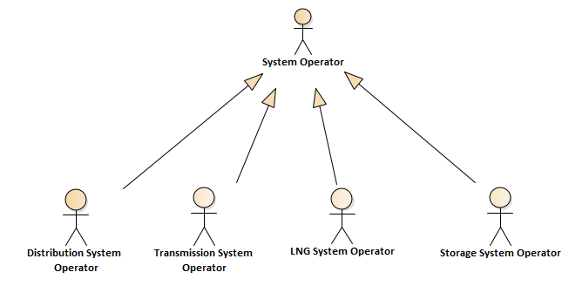

The System Operator is the parent role to the different specific roles as shown in the diagram above.

Overview of the roles in the model
The overview provides a perspective of the role model making use of only one interaction between each pair of roles in order to avoid clutter in the diagram. The interaction chosen may not necessarily be significant to some but the objective is simply to place the roles in the diagram.

Figure: 25 Overview of the roles in the model

Business Process Interactions
The following business processes are covered by the Gas Role Model:
- Capacity Allocation Process
- Gas Trading Process
o Exchange Gas Trading Process
o OTC Gas Trading Process
- Nomination and Matching Process
- Balancing and Settlement Process
o Metering Process
o Allocation Process
o Balancing Process
o Settlement Process
- REMIT and Transparency Process

Capacity Allocation Process
The Capacity Allocation Process is necessary for the implementation of a transparent and non-discriminatory system of access to and allocation of gas networks transmission capacities for all Capacity Responsible Parties.

The Capacity Allocation Process is divided into two sub process diagrams:

1. The basic capacity process includes offered capacity, auction process, allocation of capacity and credit limits.
2. The advanced capacity process includes reversed auction process, capacity surrender, curtailment and capacity transfers.

Capacity Allocation Process - Basic

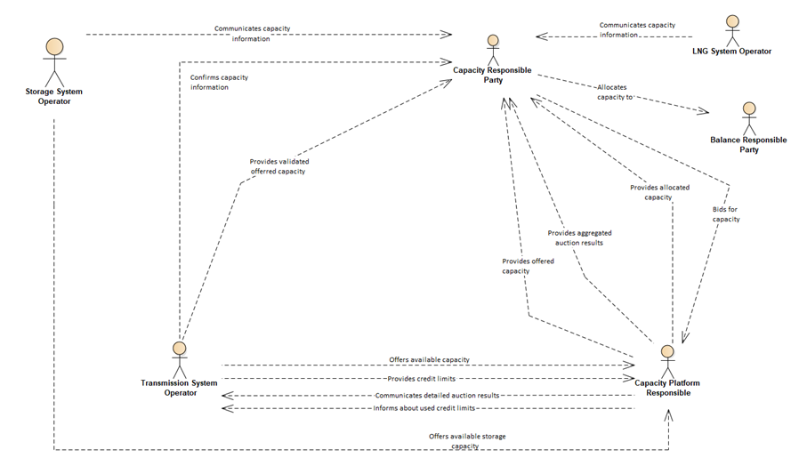
Figure: 26 Capacity Allocation Process - Basic

.

Capacity Allocation Process - Advanced

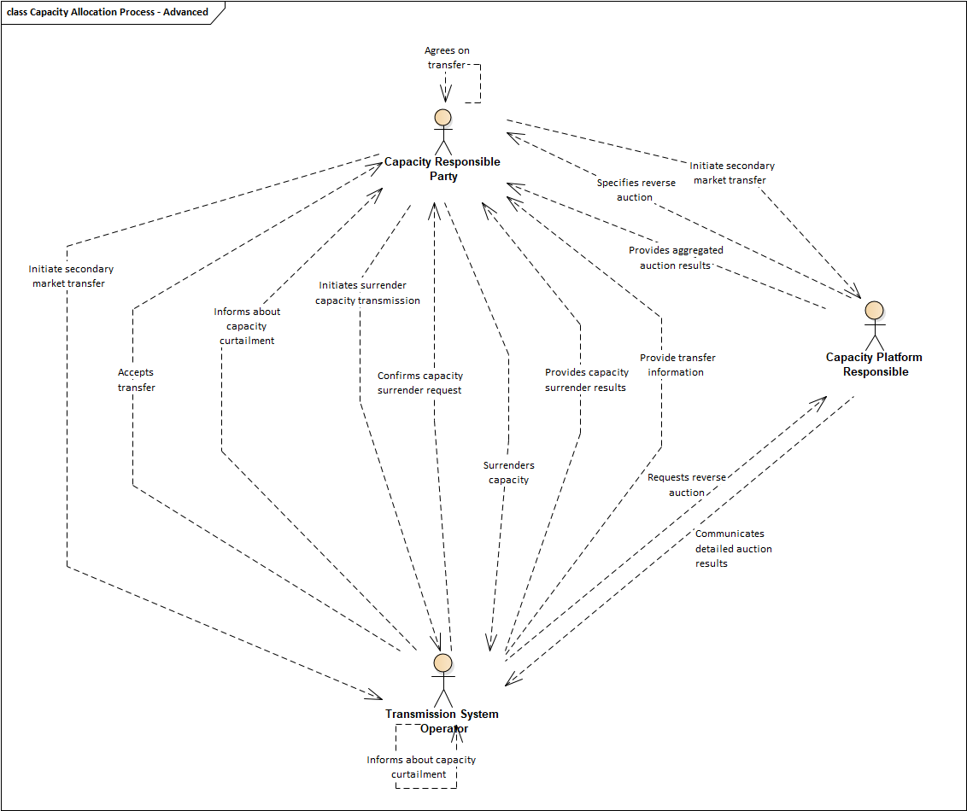
Figure: 27 Capacity Allocation Process - Advanced

Exchange Gas Trading Process
The Exchange Gas Trading Process takes place at an energy trading platform where a Trader from Party A offers a quantity of gas with a certain price for a specific delivery time and area and a Trader from another Party B agrees to the offer. Offer and agreement lead to a trade which is settled by the Clearing Responsible. The settled trade becomes a nomination which is being sent to the virtual trading point of the Area Coordinator. Usually, the nomination is being done single-sided (see Nomination & Matching process). The Balance Responsible Parties of Party A and Party B will balance their portfolios in line with the traded quantities. Area Coordinators may use the process for Area Balancing purposes.
Figure: 28 Exchange Gas Trading Process

OTC Gas Trading Process
In the OTC Gas Trading Process Balance Responsible Parties provide availability and offtake information for buying or selling gas based on bilateral contracts. These gas quantities will be used to balance the portfolio of the Balance Responsible Party.
To be able to operate gas trading contracts, Balance Responsible Parties receive input from Traders, Suppliers and Capacity Responsible Parties.
Figure: 29 OTC Gas Trading Process

Nomination And Matching Process
The Nomination and Matching Process consists of two steps:
- A nomination is the prior reporting by the Balance Responsible Party to the System Operator of the actual flow that the Balance Responsible Party wishes to inject into or withdraw from the system. Additionally, a nomination to the virtual trading point is done by the Balance Responsible Party to the Area Coordinator to indicate the traded quantities.
- Matching is the process of comparing and aligning processed quantities of gas for Balance Responsible Parties at both sides of a connection point between systems, which results in confirmed quantities for the Balance Responsible Parties. The matching on the virtual trading point confirms the traded quantities.
Figure: 30 Nomination And Matching Process

Metering Process
The Metering Process describes the interactions necessary to obtain connection point metering information, compiling the information and providing it to all interested parties.
Figure: 31 Metering Process

Allocation Process
The Allocation Process is carried out by an Allocation Responsible and consists in attributing amounts of energy to Balancing Responsible Parties at a connection point based on confirmed nominations’ quantities, metering data and the agreed allocation rule. The allocation information is provided to all concerned parties. Provisional allocations are based on non-validated metering or replacement data. Final allocations are based on validated metering data.
Figure: 32 Allocation Process

Balancing Process
In a balancing area the Balancing Process applies the rules for Balancing Responsible Parties to balance their portfolio, for Area Coordinators to inform Balance Responsible Parties about their portfolio imbalance and for Area Coordinators to undertake balancing actions to keep the balancing area within its operational limits. The portfolio imbalance is calculated based on allocation data for connection points and concluded trades on the virtual trading point.
Figure: 33 Balancing Process

Settlement Process
The Settlement Process is carried out to settle balancing actions and daily imbalance charges, to settle the difference between provisional and final allocations and also to settle reconciliation that would be necessary between the allocations and actual consumption subsequently derived from Final Customer meter readings when obtained. The Settlement Process includes the information flows between parties to perform such settlements.
Figure: 34 Settlement Process

REMIT and Transparency Process
This process defines the interactions between Transmission, LNG and Storage System Operators and the Transparency platform for the transmission of the supply and demand information, based on nominations, forecasts and realised flows in and out of the system as well as the gas contained in LNG and storage facilities in addition to available storage that is required for publication in order to ensure market transparency under Regulation (EC) 715/2009 (‘Regulation 715’).
Figure: 35 REMIT and Transparency Process

System Operations Interactions

Figure: 36 System Operations Interactions

Harmonised Gas Role Model Explanatory notes

APPLICATION AREA
The Role Model has been developed to represent actions between different market participants in the gas industry. The main focus of the document is on information exchange between market participants (excluding legal matters).
The aim of the document, however, is to provide a common terminology for the roles that are used among most European countries.
The Model is only applicable for the Gas Market and not for other Energy segments. It has been developed by EASEE-gas with input from other associations.
- Focus has been set on generic roles and not on local and national particularities.
- In the current version of this document, the number of roles has been restricted in order to ensure a good understanding for the readers.
- Edigas version 6 and subsequent versions containing the Message Implementation Guidelines are going to use the roles and interactions defined in the role model.
- Existing and future EASEE-gas CBPs will be aligned with the role model.

HOW THE ROLE MODEL WAS DEVELOPED
Roles were selected based on the existing descriptions of business processes in the gas market (ENTSOG BRS; EASEE-GAS CBP and MIG as well as Task Force participant input). European regulations and common aspects of national regulations were also considered.
For the identified roles, interactions were selected based on their need for common communication with other roles. Legal aspects (e.g. contractual relations) were not taken into account.
A concrete example is the relation between a Network User and a Shipper: Such roles are important within the gas market. However in many instances there is an overlap between them. In order to eliminate such confusion it was decided to employ the terms Balance Responsible Party and Capacity Responsible Party in their place.
LNG / Storage / Production plants: The model stops at the level of LNG Operator / Storage Operator / Production System Operator and will not go behind this. If it appears necessary, detailing activities beyond these points should be kept for a future version of the role model.

EXPLANATION OF ROLES AND PARTIES
Roles describe external business interactions with other roles in relation to the goal of a given business transaction.
A party on the market may play several roles, for example a System Operator may play both the role of Area Coordinator and the role of TSO. However two different roles have been defined since these roles are not always played by the same party.
In the gas role model not only single roles have been identified, but also parent roles. A parent role is materialised as a generalization where the connected roles inherit certain properties of the parent role. An example of a generalization is the role System Operator which has the related roles of Transmission System Operator, Storage System Operator, etc.
The different roles and interactions have been identified within the current business process at a certain moment of time. Any evolution or change in these processes could lead to an update of the Role Model.

HOW TO READ THE ROLE MODEL, HOW IS IT STRUCTURED
The overall diagram in the CBP document provides an overview of all roles and, in order to facilitate readability, only some of the major interactions between them. The diagram should help to provide a general overview of the role model.
For more detailed information, specific diagrams are provided that represent a view of each business process and the roles involved.

CHANGE AND RELEASE MANAGEMENT
Comments can be given anytime to EASEE-gas directly, email easee-gas@kellencompany.com. In the CBP section of the EASEE-gas website there is a link to the excel template for comments. EASEE-gas will collect the input and review it on regular basis. Depending on the numbers of comments, a new version will be initiated. A document change log is given in the end of the role model document.

WHERE TO FIND FORMER “SHIPPER” / “NETWORK USER” IN THE ROLE MODEL

Figure: 37 Where to find former “Shipper” / “Network User” in the role model

WHERE TO FIND FORMER “TSO” IN THE ROLE MODEL

Figure: 38 Where to find former “TSO” in the role model

Document Change Log

VERSION | MODIFICATION
2016-10-11 Prerelease 1.0 | First release of the Harmonised Gas Role Model after approval.
2016-11-01 Prerelease 1.1 | - Correction of additional interactions in figure 4  - Correction of missing interactions in figures 13, 19  - Correction of naming in figures 13, 19  - Correction of definition Clearing Responsible
2017-06-15 Prerelease 2.0 | Draft release of the Harmonised Gas Role Model from a business process perspective.
2017-07-13 Prerelease 2.1 | Approved release of the Harmonised Gas Role Model from a business process perspective.
2017-08-25 Draft 01 | - Role perspective diagrams included  - Breakdown of Settlement which includes Metering, Allocation and Balancing  - Name change from “Transparency” to “REMIT and Transparency”  - Include generic role “System Operator” in overview  - Nomination and Matching and REMIT and Transparency  - Definition of System Operator added
2017-10-11 Draft 02 | - Added bullet point with CBPs in chapter 1.1  - Renamed role PSO to PFO – Production Facility Operator  - Reworked generalizations diagram  - Renamed chapter 7.1 to Capacity Allocation  - Divided Gas Trading into 2 sub divisions “Exchange Gas Trading” and “OTC Gas Trading”  - Renamed chapter 7.4 to Balancing and Settlement  - Created 4 sub divisions – Metering, Allocation, Balancing, Settlement)
2017-12-18 Draft 03 | - Added/Modified definitions for all business processes  - Modified definition Trader  - Added interaction AC->BRP  - Added interaction Trader->Trader  - Added interaction TSO->PFO
2018-01-30 Draft 04 | - Introduction of the role Weather Data Provider  - Impact on the processes:  - OTC gas trading  - Allocation  - Balancing
2018-05-30 Stable Release V01 | - Modified business process names  - Modified business process definitions  - Process Capacity Allocation: Removed 2 interactions, added interaction  - Ensured naming coherence in processes Allocation, Balancing and Settlement  - Added loop interaction for role Market Information Aggregator  - Modified definition for role Market Information Aggregator
2019-07-26 V01 Draft A | Add information for SSO to CRP Communicates storage capacity allocation in all related diagrams.  Delete information flow SSO to CPR Communicates storage capacity allocation in all related diagrams.  BEPR to AC change the information flow direction to AC to BERP in all related diagrams.
2020-01-31 | Changes implemented to harmonise with the release of Edig@s version 6.
2022-03-03 | Harmonisation with electricity role model. Updates of role definitions and interactions. Balance Energy Price Responsible role deprecated, and added new roles for Energy Service Company, Party Administrator and Producer.
2023-10-16 | Added section and interaction diagram for System Operation  Added role generalisation illustration & text  Role definitions updated after further alignment and harmonisation
2024-11-26 | Capacity diagram divided in two sections - basic and advanced.  Added section for Remark to the expression “single-sided”  Updated definition for "Clearing Responsible"  Updated text for section 4.2.1 "Exchange Gas Trading Process"
2025-11-25 | Updated the SSO -> CRP interactions in Capacity Diagram to align with the LSO interactions.  Updated interaction CRP->TSO «Advises secondary market transfer» to “Initiate Secondary Market Transfer”  Added to new interactions in the Advanced Capacity Diagram:  - CRP->CPR. “Initiate Secondary Market Transfer”  - TSO->CRP. “Provide Transfer Information”  Implementation date column on front-page has been removed.

